**AI-Enhanced Comic Book Creator**

### **Project Description:**

The AI-Enhanced Comic Book Creator is an innovative project that leverages artificial intelligence to create comic-style visuals in response to text instructions from users. Through the integration of Hugging Face's DiffusionPipeline with the cutting-edge Stable Diffusion model, the project enables users to express scenes or narratives in simple terms, which are subsequently converted into aesthetically pleasing comic panels. This method democratizes the comic-making process, enabling those without artistic training to participate. AI-generated comic panels can be obtained by users by simply entering descriptions into a web-based platform, which increases inventiveness.

Through a simplified web application, the project seeks to provide a dynamic and engaging user experience. The AI model, which has been taught to recognize complex details and artistic styles, iteratively refines and generates high-quality images that match the input description using a diffusion-based methodology. By making it simple to portray stories, concepts, and narratives, the AI-Enhanced Comic Book Creator gives authors, educators, and content providers new opportunities. This initiative fosters creativity and efficiency by reducing the obstacles to visual storytelling, enabling users to easily realize their ideas.

### **Scenario 1: Comic Artists & Illustrators**

Professional comic artists can use this platform to speed up the ideation process by generating visual representations of their narratives. They can refine these generated visuals later to suit their unique styles.

### **Scenario 2: Content Creators & Storytellers**

YouTubers, bloggers, or storytellers can use this tool to create quick comic illustrations for their story-based content. This eliminates the need to manually illustrate scenes and allows them to focus on storytelling.

### **Scenario 3: Educational Purposes**

Teachers and educators can utilize the platform to create visual aids for educational comics. For instance, they can generate scenes to illustrate historical events or scientific concepts to better engage their students.

**Technical Architecture**

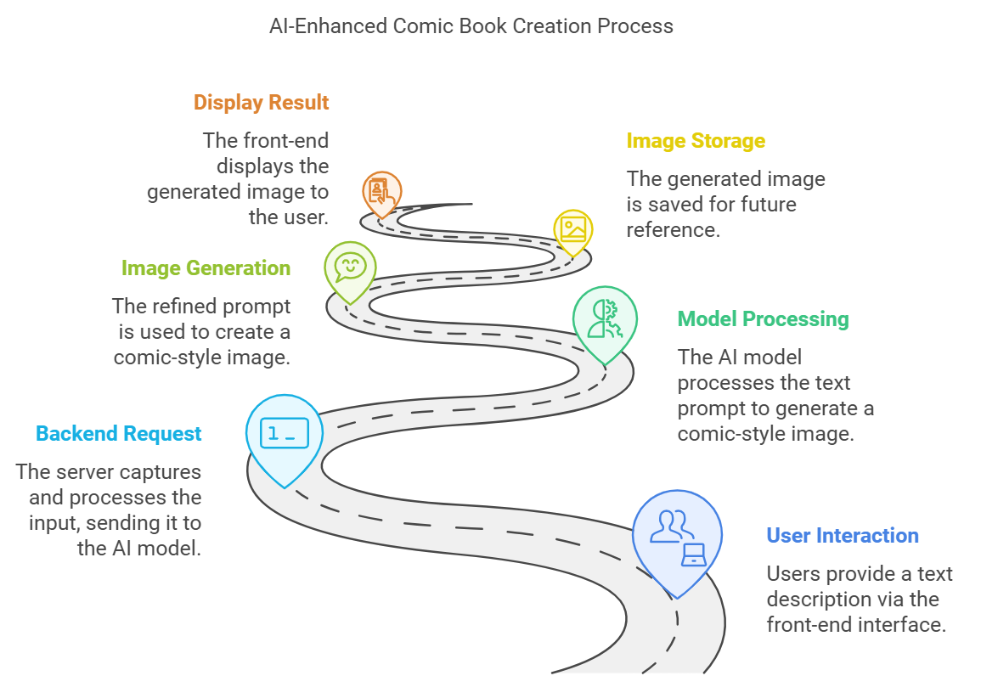

**Pre-requisites:**

### 1. Hugging Face Account Setup:https://youtu.be/Hgqi28ffeBY?si=Ad6bfBbJanPOZWTF

### 2. Python Installation and Setup: https://youtu.be/ExJHGEn6gt0?si=AMP4LFWxR8mxMO8T

### 3. Flask Web Framework Basics :https://youtu.be/4L_xAWDRs7w?si=qOD5EEKrbC9lFmC5

4.Hugging Face Inference API with Python : https://youtu.be/XMYlqm2Dq1w?si=SG6DXYfcPLS5Hq0F

### **Project Flow**

#### **1. Hugging Face Account Setup and API Access**

* **Create a Hugging Face Account:**Go to [Hugging Face](https://huggingface.co/) and sign up for an account. Generate an API access token from your account settings to interact with models.
* **Install Hugging Face Packages**Install the required Hugging Face libraries on your local machine by running the following command:

pip install huggingface-hub transformers

#### **2. Flask Application Setup**

* **Install Flask**Set up Flask to create a web interface for docstring generation. Install Flask using the following:  
  pip install Flask
* **Create Flask App**Build the backend logic to process the user's code and call the Hugging Face model for generating docstrings. Define routes for the web app and handle user input.

#### **3. Frontend Development**

* **Develop Frontend UI**Create the frontend interface using HTML, CSS, and JavaScript. Add a simple form where users can input their Python code and a button to comic generation.
* **Integrate CSS Styling**Design and implement a user-friendly interface with styled buttons, text fields, and background images to enhance the user experience.

#### **5. Model Fine-Tuning (Optional)**

* The input text is sent to the backend, where the **Stable Diffusion** model processes it to generate a comic-style image.
* The generated image is saved, and the web app displays the comic to the user, who can choose to download or continue generating more images.

#### **6. Testing and Debugging**

The text prompt is sent to the backend, which uses **Hugging Face’s DiffusionPipeline** to process the input and generate a comic-style image. The pipeline is pre-trained on large datasets and fine-tuned using specific techniques to adapt the model to comic art styles.

#### 

#### 

#### **7. Deployment**

* **Deploy the Flask App**Deploy the Flask application to a live environment, ensuring that the application is properly connected to the Hugging Face API and able to handle multiple user requests.

This project flow gives a structured approach to building and deploying the AI - enhanced comic creation.

**Milestone 1: The Model Chosen and Its Details, Architecture**

#### **1. Model Chosen: Stable Diffusion**

Stable Diffusion is a state-of-the-art **text-to-image model** that leverages **diffusion processes** to iteratively refine and enhance random noise until a high-quality image is produced. It's designed to generate images from text descriptions, offering precise control over style, quality, and content.

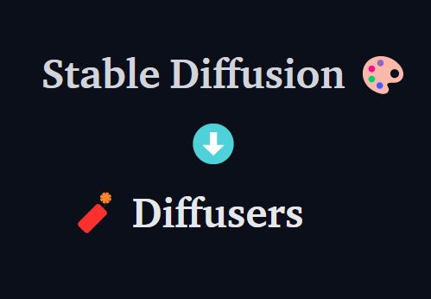

#### **2. Model Details**

* **Model Name:** Stable Diffusion
* **Model Type:** Latent Diffusion Model (LDM)
* **Architecture:** Diffusion-based model
* **Hosted on:** Hugging Face
* **Input Format:** The model accepts user prompts in the form of text descriptions starting with Comic strip on...
* **Output:** The model produces an image based on the text prompt. The **diffusion process** in Stable Diffusion progressively refines the initial image to align with the user’s input.

#### **3. Model Architecture**

Stable Diffusion primarily relies on two main components:

* **Text Encoder**: Converts textual descriptions into embeddings.
* **Diffusion Model**: Generates images from these embeddings through a series of denoising steps.

### **- >Key Components**

#### **a. Text Encoder**

* **Transformer Architecture**: Stable Diffusion utilizes a transformer-based architecture (often CLIP) to encode input text into a fixed-length vector representation. This helps the model understand the semantics of the text.
* **CLIP (Contrastive Language–Image Pretraining)**: A pre-trained model that maps text and images to a shared latent space, allowing it to understand and generate images based on textual prompts.

#### **b. Latent Diffusion Model (LDM)**

* **Latent Space**: Instead of working directly in the pixel space, Stable Diffusion operates in a lower-dimensional latent space, significantly reducing computational requirements and speeding up the process.
* **U-Net Architecture**: The core of the diffusion model is often a U-Net, which is an encoder-decoder network. It includes:
  + **Downsampling Path**: Reduces the spatial dimensions while increasing the number of channels to capture high-level features.
  + **Bottleneck**: Connects the downsampling and upsampling paths, where most of the computation occurs.
  + **Upsampling Path**: Gradually reconstructs the image from the latent representation back to the original size.

#### **c. Diffusion Process**

* **Forward Process**: Gradually adds Gaussian noise to the image over a series of time steps, effectively training the model to learn the distribution of the images.
* **Reverse Process**: The trained model learns to reverse the noise process, generating images from noise conditioned on the text embeddings.

#### **d. Cross-Attention Mechanism**

* The U-Net includes cross-attention layers that allow the model to focus on specific parts of the text embedding while generating each pixel of the image, ensuring that the generated image aligns closely with the provided text.

### **-> Training Process**

* **Data Collection**: The model is trained on a large dataset of image-text pairs.
* **Denoising Objective**: The training objective is to minimize the difference between the original image and the reconstructed image at various noise levels.

### **-> Inference**

* At inference time, a random noise tensor is sampled, and the model iteratively refines this tensor using the learned reverse diffusion process, guided by the text embeddings, until a coherent image is generated.

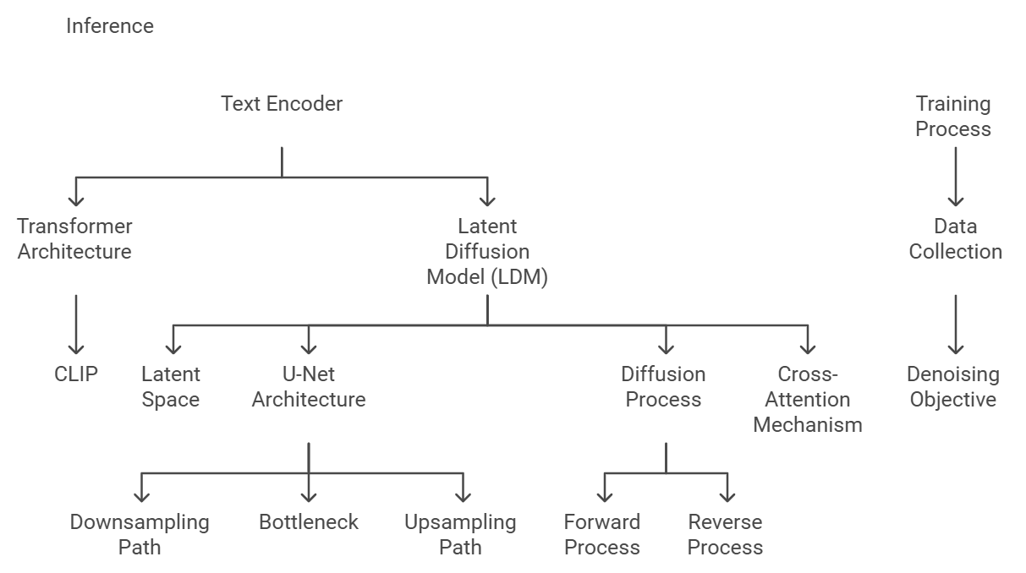

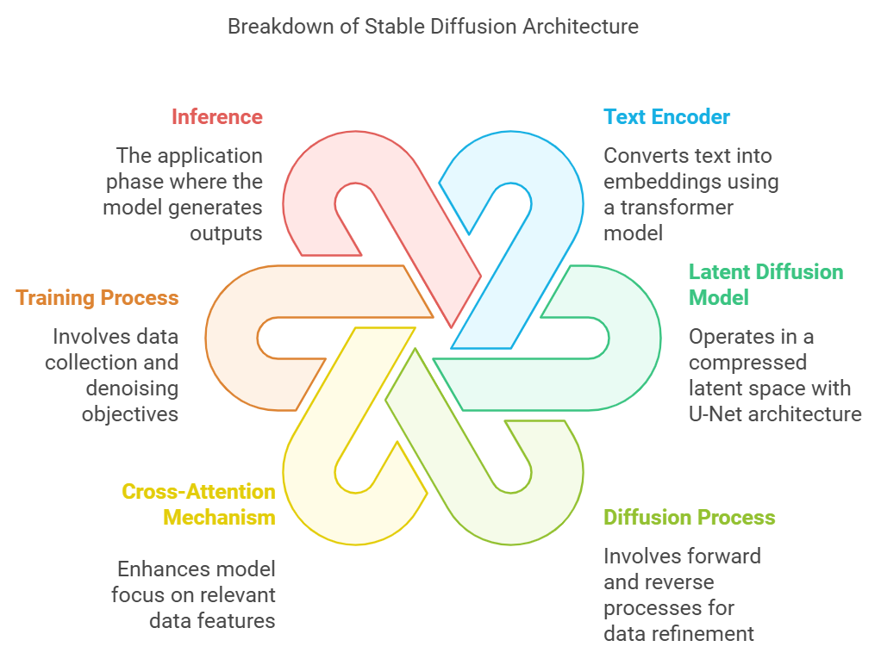

This format allows for easier navigation through the various aspects of the Stable Diffusion architecture.

**Milestone 2: Project Functionalities**

**Model Training and Setup:**

* The Pretrained Stable Diffusion model is loaded using the **Hugging Face DiffusionPipeline**.
* Fine-tuned with **LoRA weights** to adapt the base model to comic-book styles.

**Integration with the Web Application:**

* Implemented in a **Flask-based backend** that handles incoming requests from the front end and sends the generated image as a response.

**User Interaction:**

* Users input text prompts which the backend uses to invoke the model, generating the comic.

The project leverages **Stable Diffusion**, which is a state-of-the-art AI model for generating images from text. It uses a process called **diffusion**, which iteratively refines and improves an image to align with a given text prompt. The integration with **Hugging Face’s DiffusionPipeline** allows for easy deployment and customization of the model to suit specific needs.

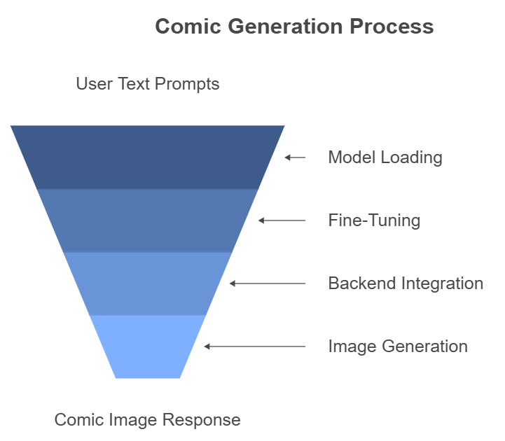

**Milestone 3: Web Development**

The web application was developed using HTML, CSS, and Flask. The front end has three main pages:

1. Home Page: Introduces the app and provides instructions for using the tool.
2. Input Page: Contains a form where users can input their text description.
3. Display Page: Shows the generated comic image with an option to download.

The backend uses Flask to manage routes and handle model inference. Jinja templates were used for dynamically rendering HTML pages, and the comic images are stored in a static folder.

#### **Create the Flask Application Structure**

**Application Directory Structure**: Ensure the following directory structure is in place:  
  
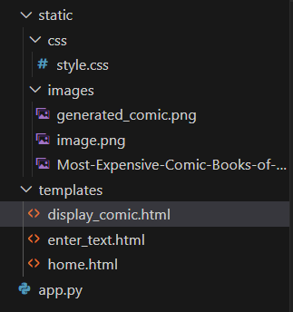

**Home.html:**

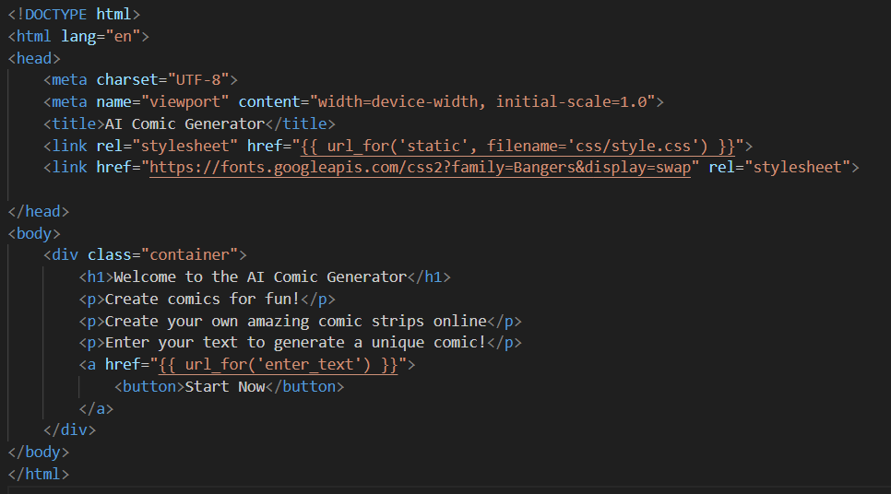

**Enter_text.html:**

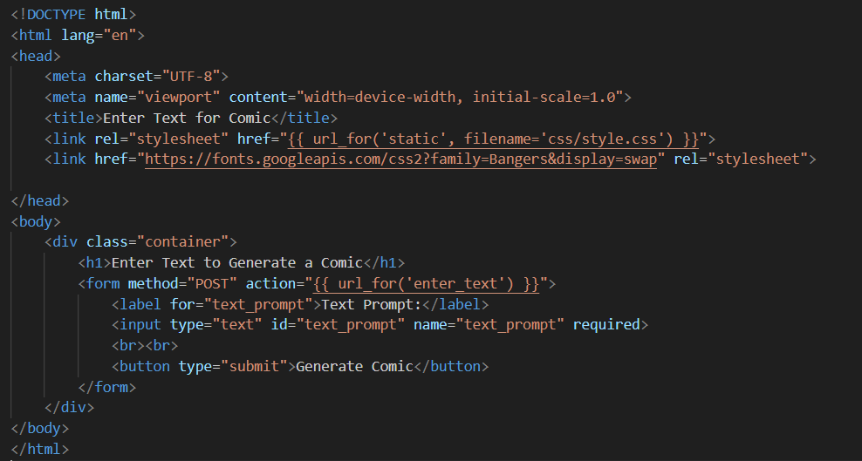

**Display_comic.html:**

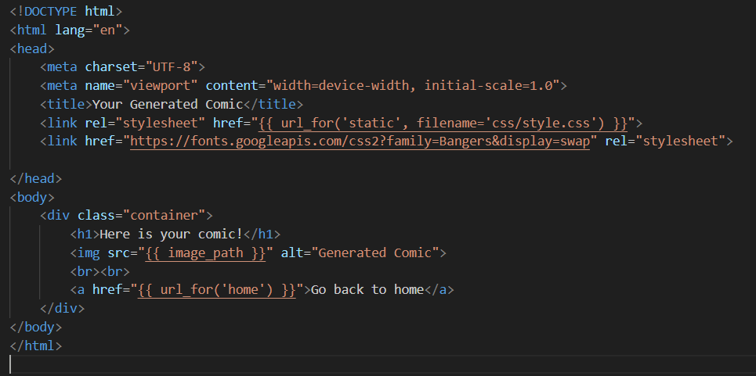

#### **1. Flask Framework Setup**

* **Description: Flask is a lightweight Python web framework that was used to build the web application. It allows for handling HTTP requests and rendering HTML templates.**
* **Components:**
  + **Importing necessary Flask modules (Flask, render_template, request, etc.).**
  + **Setting up routing for the application, including the home page and the page where the docstring is generated.**

**app.py Code Snippet:  
  
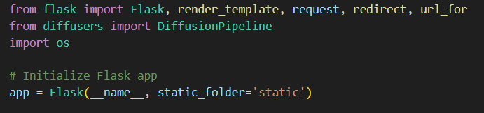**

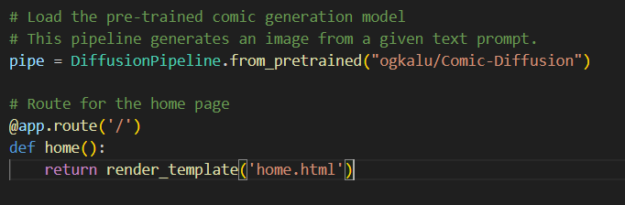

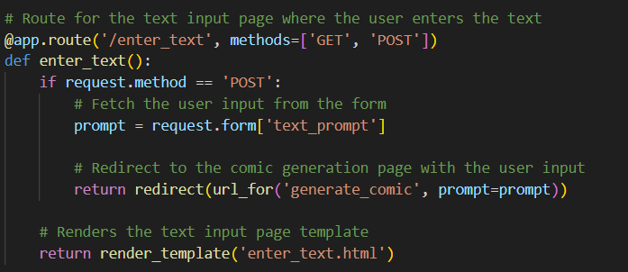

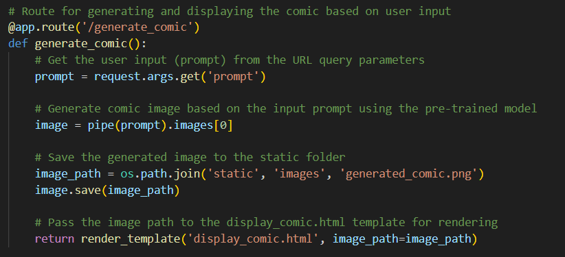

#### **7. Deployment-Ready Structure**

* **Description:** The app.py file is structured for easy deployment. It contains all the necessary components for the web app to be deployed on a cloud server or locally.
* **Components**
* Flask’s development server is started via the app.run() method.
* Environment-specific configurations can be added (e.g., debug mode, production mode).

**Key Code Snippet:  
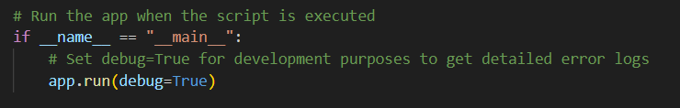**

**Key CSS Snippet:**

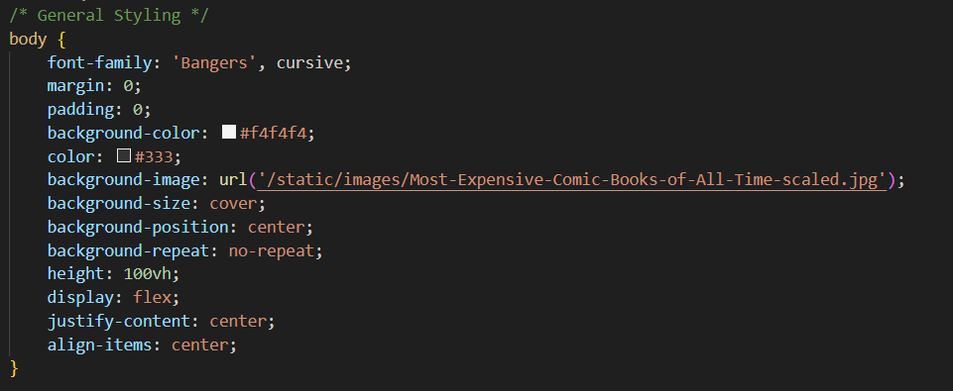

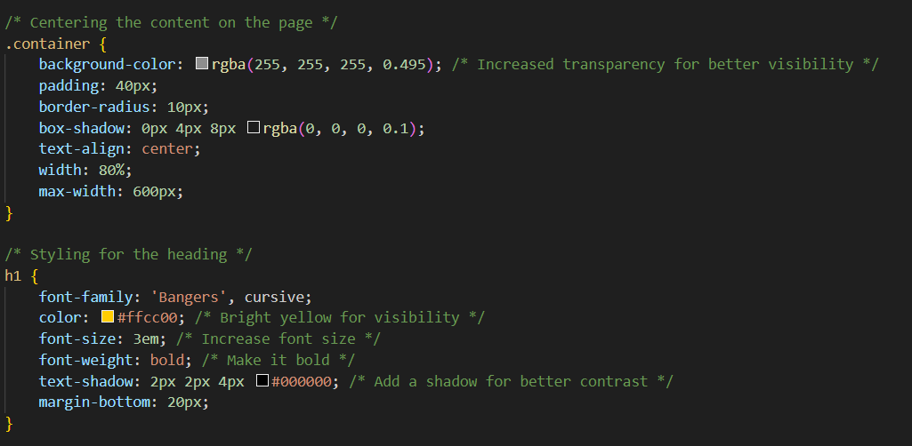

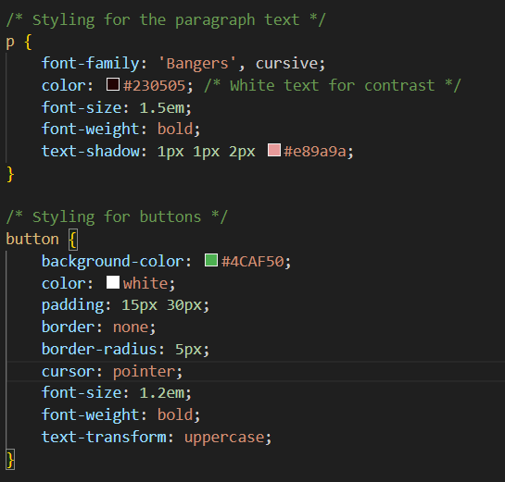

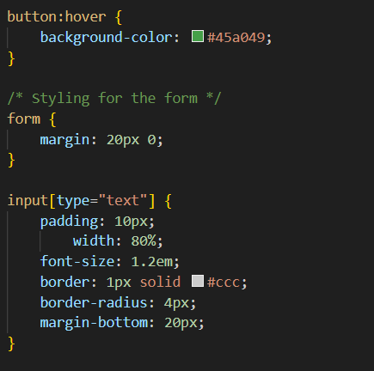

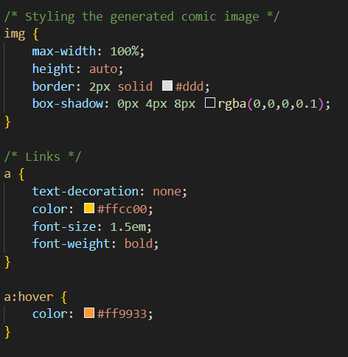

**Milestone 5: Deployment**

1. **Preparation and Setting Up Environment**

* Ensure Python 3 is installed on your local machine.
* Install necessary libraries such as Flask and the Hugging Face API client by running the following commands in the terminal:

pip install flask huggingface_hub



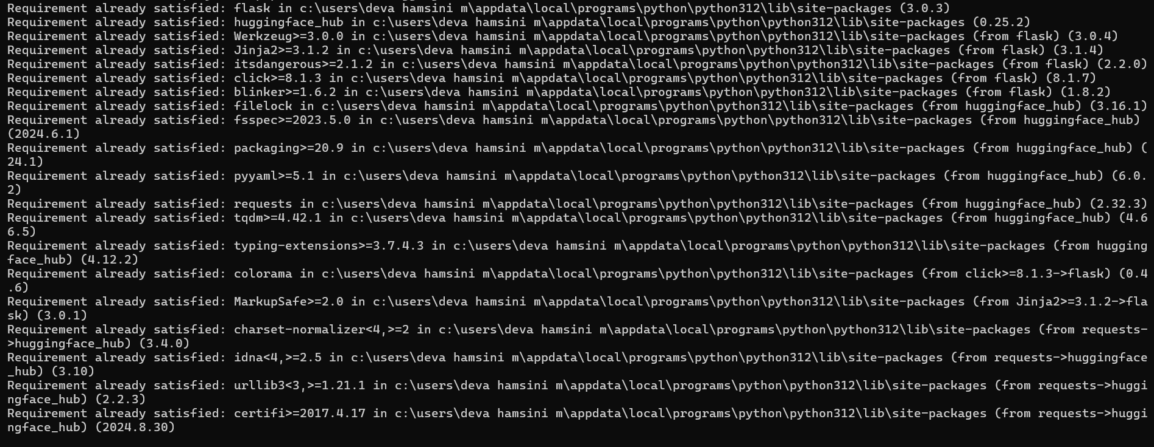

#### **Install required libraries**

In the project directory, we created a requirements.txt file to list all the dependencies which is :

To install them, use:



1. **Running the Flask Application**

* Place the app.py and other related files such as templates and CSS in a local directory.
* To run the app locally, use the following command in the directory where your app.py is located:



* Once the Flask app starts running, it will provide you with a local link, usually something like:

Running on http://127.0.0.1:5000/ (Press CTRL+C to quit)

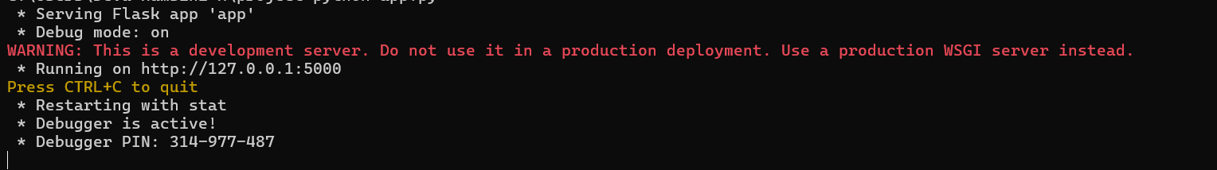

Open the provided URL in your browser to access the Python docstring generator interface.

1. **Testing the Application**

**OUTPUT:  
HOME PAGE**

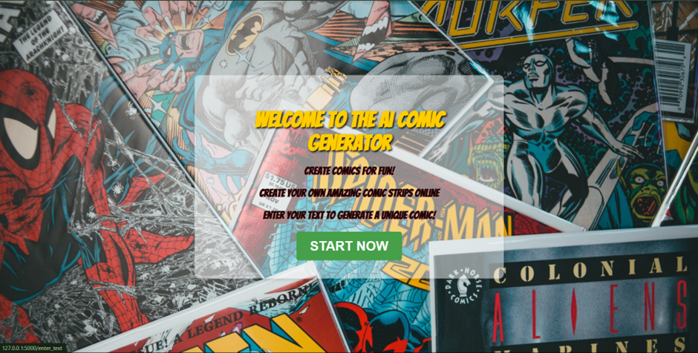

INPUT PAGE

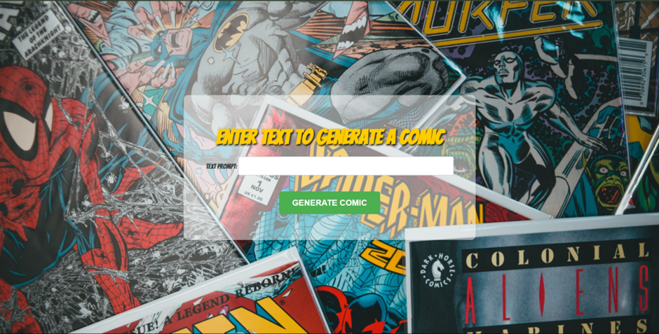

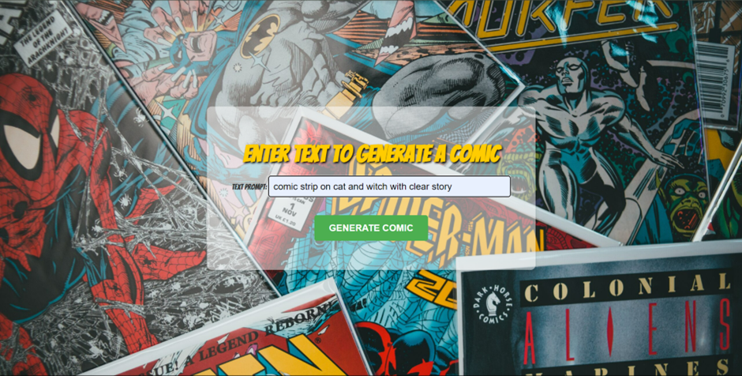

OUTPUT PAGE

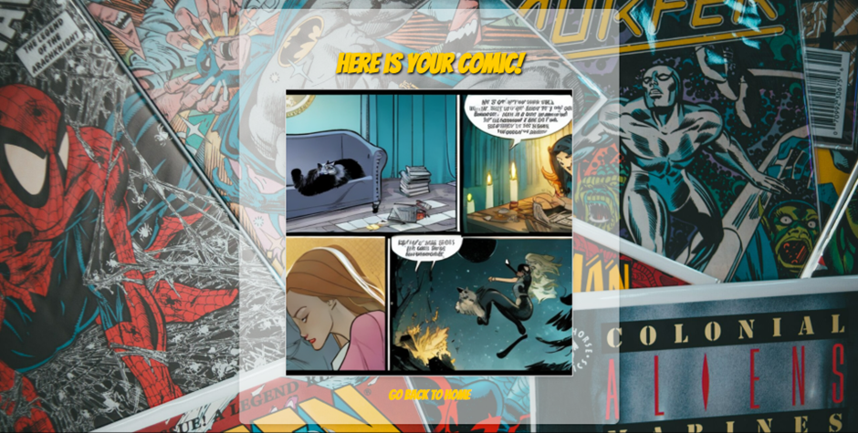

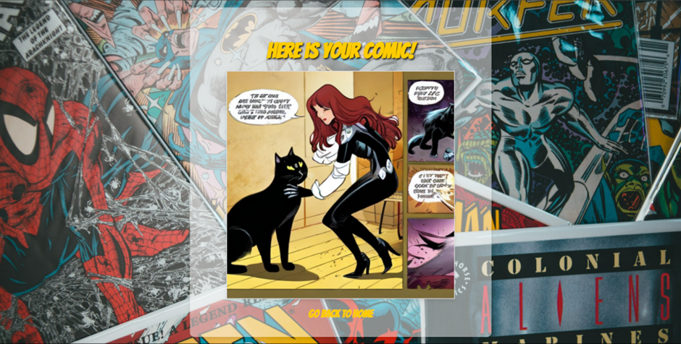

**Conclusion**

By combining cutting-edge AI models with a user-friendly web interface, the **AI-Enhanced Comic Book Creator** provides a new and innovative way to create visual content. The project not only reduces the manual labor traditionally required in comic illustration but also makes the process more inclusive, enabling anyone with a creative idea to bring it to life. The use of **Stable Diffusion** offers detailed and contextually accurate images, while the integration with a web application ensures ease of use for all types of users.